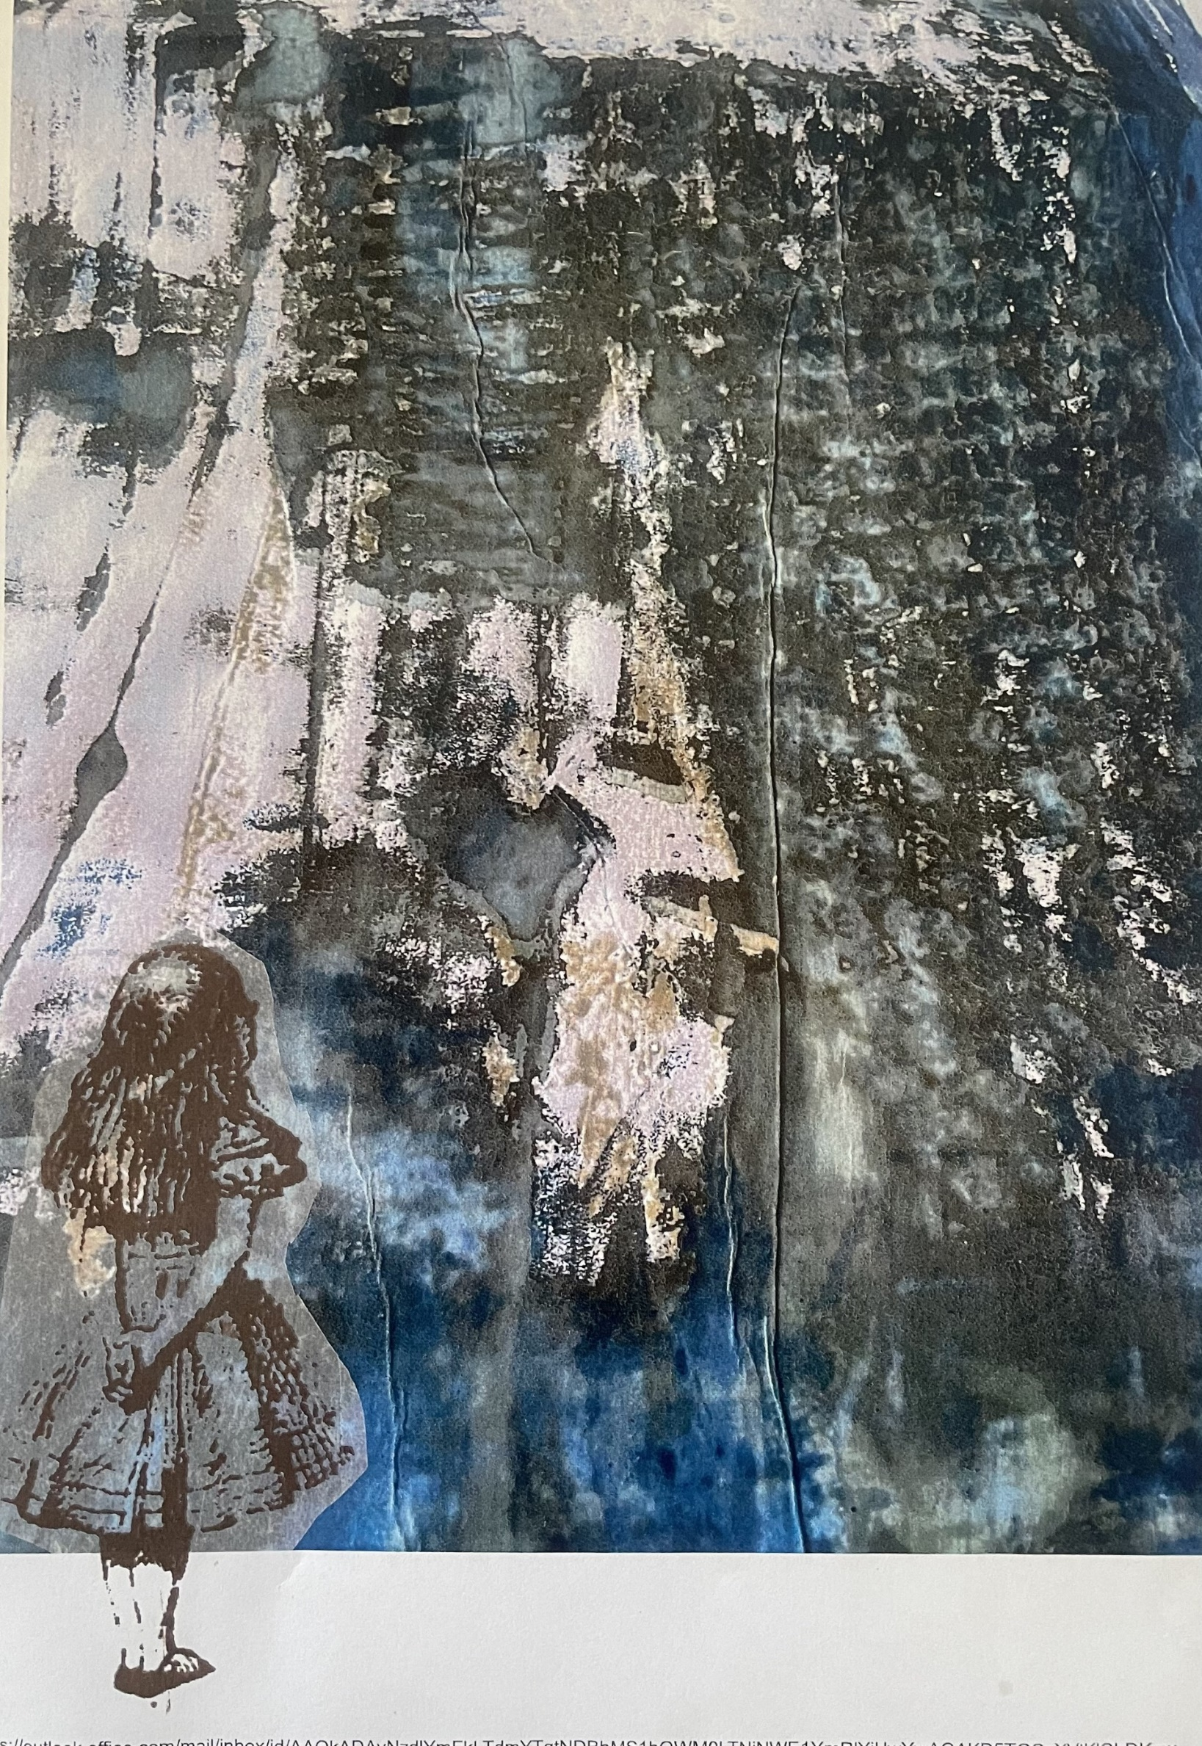
“Down the Rabbit Hole”

An Exhibition of Fine Art and Textile Designs
Inspired by the adventures of
“Alice in Wonderland”

Gallery 13a
Friday Street
Minehead

Tel: 07854 110869
Open Wednesday – Friday 10.30 – 5.00
Saturday 10.30 – 1.00
www.juliareesdesign.co.uk

“Down the Rabbit Hole”

An Exhibition of Fine Art and Textile Desings
Inspired by the adventures of
“Alice in Wonderland”

Gallery 13a
Friday Street
Minehead
TA24 5UB

Tel: 07854 110869
Web site htps://www.juliareesdesign.co.uk

Open Wednesday – Friday 10.30 – 5.00
Saturday 10.30 – 1.00

